
Ms O’Connor BY1.7 Cell Division
As Biology
Name:
Set:

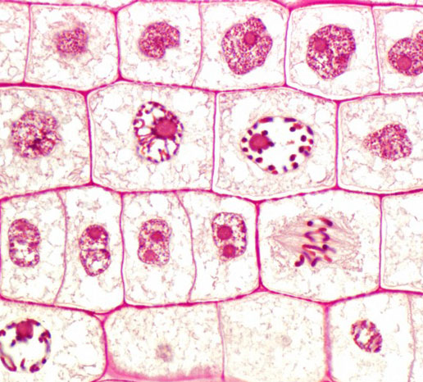

Cell Division Syllabus Points
Mitosis
- Mitosis results in genetically identical daughter cells.
- Explain the significance of mitosis in growth, cell replacement / regeneration, and asexual reproduction.
- Describe the behaviour of chromosomes during interphase and the main stages of mitosis -, prophase, metaphase, anaphase and telophase.
- Recognise the mitotic stages from diagrams, prepared slides and photographs.
Meiosis
- State that meiosis occurs during sexual reproduction, when it is important that haploid gametes are produced.
- Describe how meiosis produces four genetically different cells and involves two consecutive divisions. (no details of the stages of meiosis are required.)

Mitosis
Can you label and explain what happens in each of the stages?

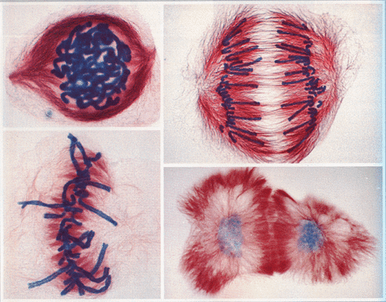

Mitosis is a continuous process but for convenience of description is divided into FOUR MAIN STAGES:
- P_________
- M________
- A_________
- T _________
INTERPHASE
- Prior to mitosis the cell is in a stage called interphase
- 3 key occurrences in interphase ______________________________________________________________________________________________________________________________________________________

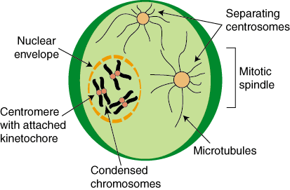
PROPHASE

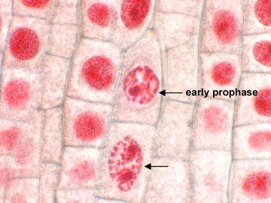

Your own picture:

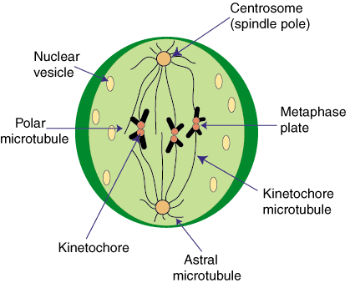
METAPHASE

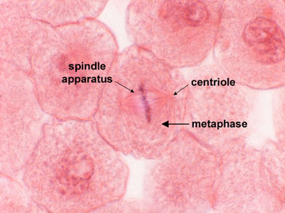

Your own picture:

ANAPHASE
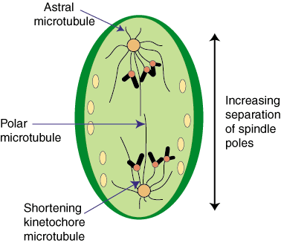

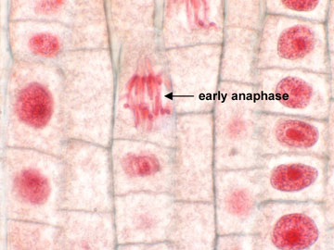

Your own picture:

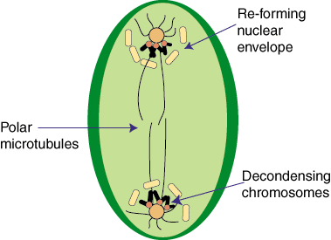
TELOPHASE

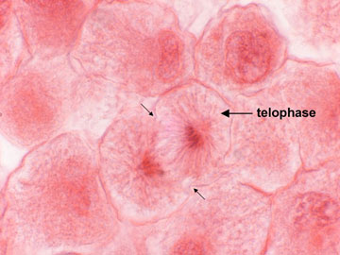

Your own picture:

CYTOKINESIS IN ANIMAL CELLS
- There are two separate nuclei in the same cell. The cell needs to be split in half
- Begins in anaphase and continues through telophase
- Cell puckers in, ‘furrowing’
- Takes place at right angles to the mitotic spindle, so that each nucleus is placed in a separate globule of cytoplasm
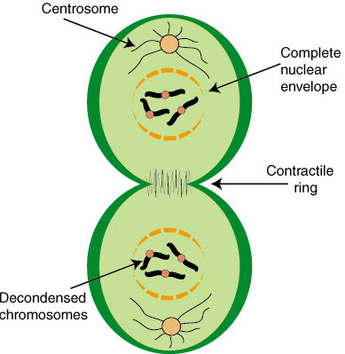

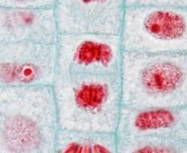

Stages of Mitosis: Root Tip Squash

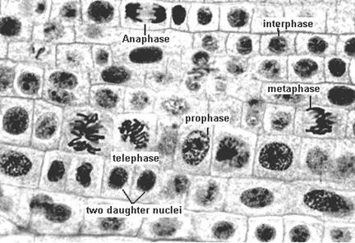
In this experiment we will try to observe cells from an onion or garlic root which are actively diving and going through the process of mitosis. We will also try to calculate the mitotic index and gain an idea of the length of each stage of mitosis.

1. Remove approximately 2cm. of a developing root.
2. Place the root in a watch glass containing acetic orcein and M HCL in the approximate proportions of 10 parts stain to 1 part acid.
3. Warm in the oven at 60ºC for 5 mins. Prepare the sheet you will do your drawings on at this time (title, date, name and names of phases)
4. Remove root and discard all but the tip (2mm.) – place tip on a clean microscope slide. Add 2 drops acetic orcein.
5. Carefully squash root with a vertical tapping motion using a flat ended glass rod.
6. Add a cover slip, place between two layers of filter paper and squash firmly but carefully. Do not move the cover slip from side to side!
7. Warm the slide in the oven for a further 10-15 seconds.
8. Examine for stages in mitosis. If the cells are overlapping, squash the slide down a bit more, a but avoid moving/smearing the cover slip.
9. Draw, label and annotate each of the four named stages of mitosis.
10. If after 5 minutes of looking, you cannot identify any phases of mitosis, get a pre-pepared onion root tip slide and make observations from that slide instead.
11. Now examine at least 10 different field of views. N each count the number of cells in each stage and keep a tally for the total. Draw a pie chart of your results (the ‘Mitotic Index’) and use it to make some suggestions as to the length of each stage of mitosis.

The Mitosis Cell Cycle & The Importance of Interphase
You will save time by reading all the instructions and the success criteria and tasks before starting.
The below criteria will help you complete task 1-3. It is cumulative, so each grade must be achieved before the next can be reached. Two criteria can be completed within a single diagram/answer.

Success Criteria:
- State the four purposes of mitosis (E)
- Draw an annotated cell cycle diagram outlining each of the stages of the cell cycle (D)
- Outline the order of events in the entire cell cycle and what happens within each stage of the cell cycle including interphase (C)
- Explain the importance of DNA and organelle synthesis occurring (including when these two event happen) (B)
- State the name of the disease and describe the result results of unrestricted cell growth by mitosis (A)
- Research the significance of the P53 and BRCA1 genes in this disease (A*)

Use information in the resources below to help you with the above task:
www.msjoconnor.weebly.com
http://cellsalive.com/mitosis.htm
http://cellsalive.com/cell_cycle.htm
http://www.cancerresearchuk.org/about-cancer/cancers-in-general/what-is-cancer/cells/the-cancer-cell
http://www.nature.com/scitable/topicpage/cell-division-and-cancer-14046590
http://www.breastcancercampaign.org/about-breast-cancer/breast-cancer-risk- factors/family-history-and-genetics/brca-gene-mutations-and-breast-cancer

Comparing Mitosis and Meiosis
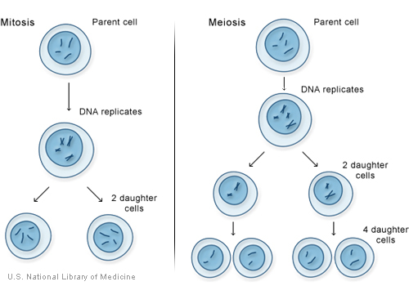

Cells (gametes) produced by meiosis need to be haploid because …………………………………………………………………………………………………………………………………………….
Chromosome number in a haploid gamete (from meiosis) is represented by:
………………
Chromosome number in a diploid cell (mitosis) is represented by:
………………
Two key differences in the process of meiosis that allows it to create ‘unique’ daughter cells are:
1. …………………………………………………………………………………………………………………………………………
2. ………………………………………………………………………………………………………………………………………..

The steps of meiosis
………………………………………………………………………………………………………………………………………………
An acronym to help you remember interphase and the steps of meiosis
…………………………………………………………………………………………………………………………………………………

Table of MITOSIS-MEIOSIS Comparison
Feature | Mitosis | Meiosis
Definition

Occurs in (cell type)
Number of divisions
Number of daughter cells produced
Genetic Composition
Creates (type of cell)
Genetically / Type of Reproduction
Function / Importance in Body
Human Chromosome number

Mitosis & Meiosis
Genetic Information vs Genetic Material

Phases of mitosis (not in order): G2, G1, G0, S, M (mitosis)
Phases of meiosis (not in order): G2, G1, G0, S, M1, M2 (meisosis 1 & 2)

Add the correct letters in the correct boxes to represent the phases of meiosis below the diagrams. For example the point at which genetic material goes down in the first mitosis diagram would be during M (mitosis).
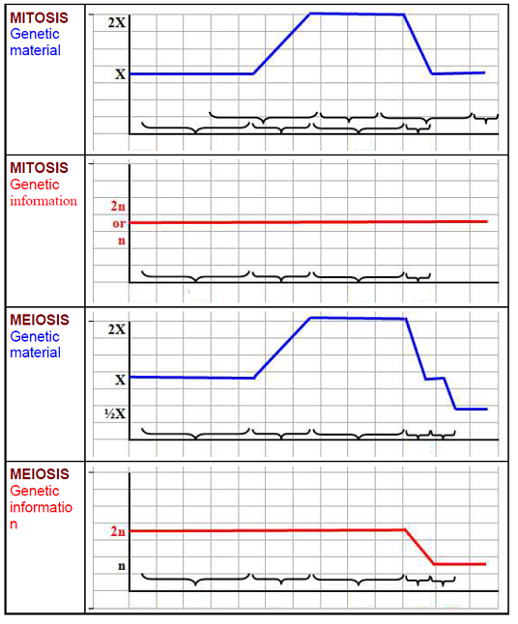
Why does the line go up/down when it does?
…………………………………………………………………………………………………………………………………………………………………………………………………………………………………………………….
Why is it a flat-line all the way through?
…………………………………………………………………………………………………………………………………………………………………………………………………………………………………………………….

Why up once and down twice? What phases are each of these happening in?
…………………………………………………………………………………………………………………………………………………………………………………………………………………………………………………….
When and why does genetic information go down?
…………………………………………………………………………………………………………………………………………………………………………………………………………………………………………………….

